Finding USGIN State Geothermal Data services

Question: How do I find data services that have been put online by the DOE National Geothermal Data System State Geothermal Data project?

In your web browser, go to

<http://metadata.stategeothermaldata.org/search/service>

(this URL searches that metadata repository for datasets that have service access)

The page should look something like this:

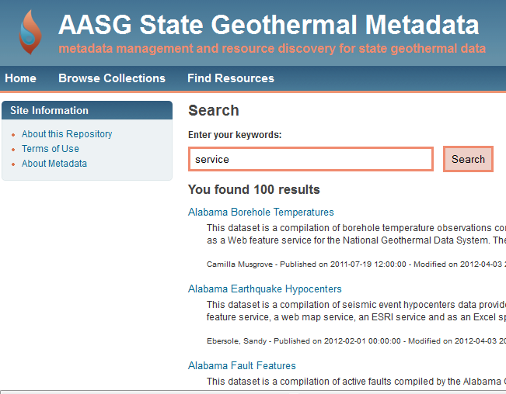

Click on one of the blue links to see the metadata (example ‘Alabama Earthquake Hypocenters’)

The result should look something like this:

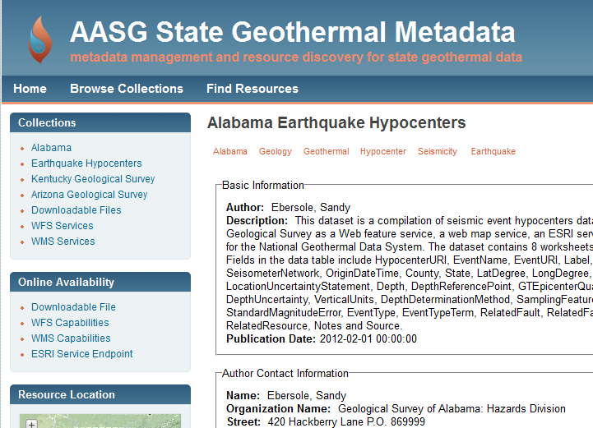

In the left center of the window is the ‘online availability’ section that provides links to access the described dataset online. WFS is OpenOGC Web Feature Service (for accessing the data), WMS is OGC Web Map Service (to get a georeferenced picture of the data, with a getFeatureInfo single point operation), ESRI Service Endpoint is a link to an ArcGIS server REST page. The ISO XML metadata record that is displayed by this web page can be accessed at <http://metadata.stategeothermaldata.org/resource/50b3a9b3bec98d3d491e2187c524c92e/iso.xml>. The linkage information for the different services is encoded according to convention in the ISO XML metadata like this:

<gmd:MD_DigitalTransferOptions>

<gmd:onLine>

<gmd:CI_OnlineResource>

<gmd:linkage>

<gmd:URL>http://kgs.uky.edu/arcgis/services/aasggeothermal/ALEarthquakeHypocenters/MapServer/WFSServer?request=GetCapabilities&amp;service=WFS</gmd:URL>

</gmd:linkage>

<gmd:protocol>

<gco:CharacterString>OGC:WFS</gco:CharacterString>

</gmd:protocol>

<gmd:name>

<gco:CharacterString>serviceDescription</gco:CharacterString>

</gmd:name>

<gmd:description>

<gco:CharacterString>WFS</gco:CharacterString>

</gmd:description>

<gmd:function>

<gmd:CI_OnLineFunctionCode codeListValue='381' codeList='http://www.fgdc.gov/nap/metadata/register/registerItemClasses.html#IC_88'>webService</gmd:CI_OnLineFunctionCode>

</gmd:function>

</gmd:CI_OnlineResource>

</gmd:onLine>

</gmd:MD_DigitalTransferOptions>

The [USGIN metadata profile](http://repository.usgin.org/uri_gin/usgin/dlio/337)  defines conventions put forth to enable automated processing of these kind of service distribution links in metadata, such that a search client operating inside of e.g. ArcMap (see <http://lab.usgin.org/applications/doc/csw-client-application>) could search the catalog and add data to a project with minimal user intervention.